CITY OF MERCER ISLAND  COMMUNITY PLANNING & DEVELOPMENT  9611 SE 36TH STREET | MERCER ISLAND, WA 98040  PHONE: 206.275.7605 | www.mercergov.org | 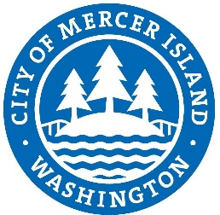
Meeting Sign In Sheet
Project Address: Meeting Date: Application No:
Name | Organization/Department | Email | Phone Number
Name | Organization/Department | Email | Phone Number

